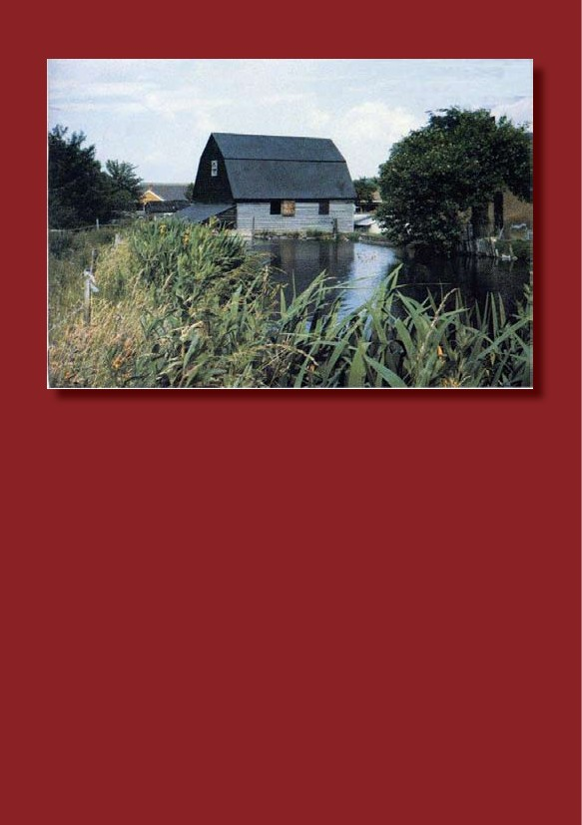
FORD END WATERMILL
IVINGHOE
BUCKINGHAMSHIRE
HISTORIC WATERMILL

Welcome to Ford End Watermill
Ford End is a small farm mill, which has produced flour and animal feed for
centuries. Although clear evidence of its early existence on the site has not been
found, a possible reference to it was made in a document of 1232. It was later
suggested that, in 1346, the mill belonged to the Neyrnut Manor at nearby Pitstone
Green and the 'Victoria County History of Buckinghamshire' referred to ownership of
a mill in Ivinghoe during the 14th Century. There are further references in 16th
century documents to a mill in Ivinghoe however these do not identify the site
positively as that of the mill at Ford End. The oldest verifiable date for the mill is a
parish record of 1616.
It is understood that the present mill building replaced an earlier one but when is not
known. A reasonable assumption is that the mill building dates from the early years
of the 18th century as it appears to have been well established by 1767.
Documentation from that time records that Ford End was owned by a Mrs Judy
Reddall and tenanted by Bernard Wilkes. In 1784, he was succeeded by William
Heley who worked the farm and mill until 1798. In that year, the mill is mentioned in
the 'Posse Comitatus', a survey prepared by the county as part of the precautionary
preparations against possible French invasion during the Napoleonic Wars. The
Buckinghamshire survey lists 97 watermills including one in Ivinghoe occupied by
William Heley, who was 'grinding 16 sacks a week'. You will find the initials and
date, 'W H 1795', painted on a board on the wall of the first floor of the mill building
reinforcing this association.
From 1798, the mill was owned by George Griffin and then, in 1826, the mill was
purchased by the Bridgewater (Ashridge) Estate. During the second half of the 19 th
Century, the main tenant was William Tompkins, known locally as 'Miller Tompkins'.
On his death in 1886, he was succeeded by his second son Moses, whose own
death in 1890 without issue brought the family tenancy to an end. In 1903, Charles
Jellis was listed as the 'farmer and miller (water)' and he bought the farm and the mill
from the Brownlow (formerly the Bridgewater) Estate in 1924. Five generations of
the Jellis family have since owned Ford End and Paul Jellis farms here today (2013).
By 1963, however, the mill had fallen into such a poor state of repair that it was
barely usable. In 1965, the Pitstone Local History Society came to an agreement
with Arthur Jellis, Paul’s grandfather, regarding the conservation of the mill and
carried out major repairs to the waterwheel and penstock* (sluice gate) to enable
the mill to become operational once more. Over the next eleven years, general
repairs and renovations led to the mill being opened to the public on the August
Bank holiday weekend of 1976. It was to be another fifteen years before, on the
24th June 1991, the mill machinery was sufficiently restored to enable the mill once
more to produce flour. Visitors have been coming to the mill ever since exploring its
machinery, experiencing its operation, and taking home its wholemeal flour.
*
Milling terms highlighted in bold are described more fully in the Glossary at the end of the Guide
2

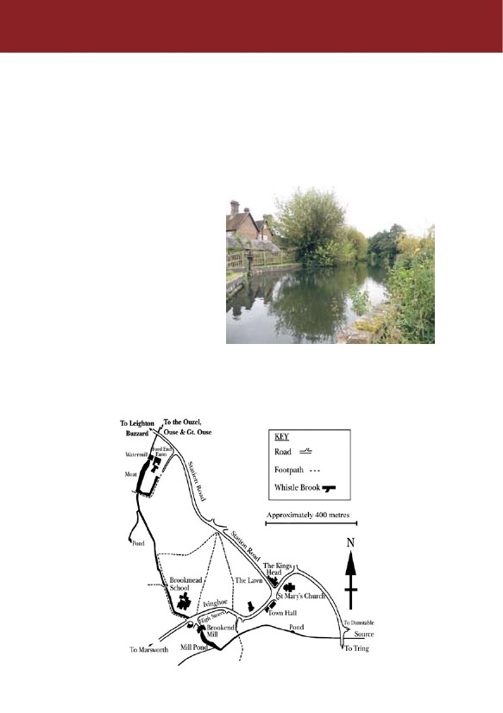
Guided Tour
We hope you enjoy your visit. Please take care when the mill’s machinery is in
operation and when ascending or descending stairs. As you will understand,
no smoking is permitted inside the mill.
The Millpond
The tour begins outside the mill
building. Cross the small bridge
below the mill, walk up by the side
of the building, past the
waterwheel and finally climb the
few steps to the summit. Here you
will be rewarded with a view of the
millpond.
The millpond was formed from the
remains of what was once a
rectangular moat, believed to have
surrounded the original 13th
century farmhouse. That
farmhouse was replaced in the early 19th century by the present one built by the
Bridgewater Estate. As well as offering a useful protective barrier, the moat would
have more importantly provided an additional source of fresh food – fish, waterfowl,
cress and fresh water mussels.
3

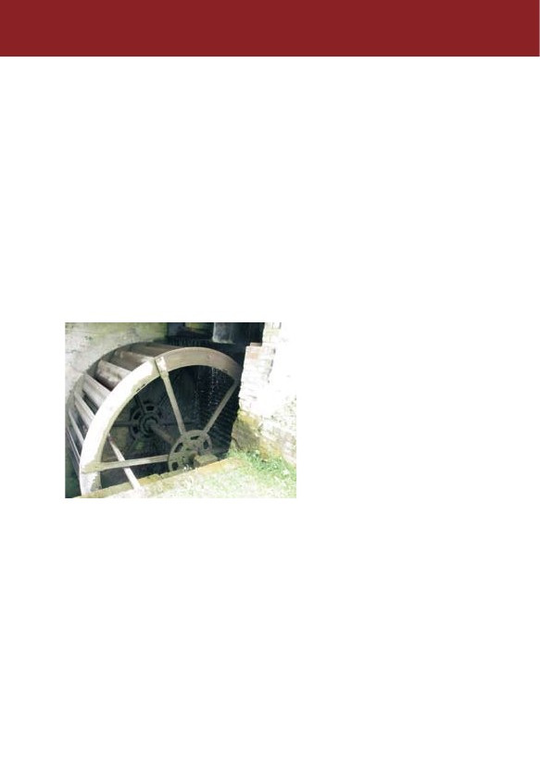
The water supply to the millpond is provided by the Whistle Brook, whose source is a
spring from the underlying water-bearing chalk in the field south of the Dunstable
Road (see map on Page 3). The small stream flows down under the Tring Road,
crossing the field to the south of the village and forming the parish boundary between
the parishes of Pitstone and Ivinghoe. After passing under Brookend Mill (formerly
the Pitstone Watermill, now a house) and the Marsworth Road, the stream re-
emerges to skirt Brookmead School, is joined by two small tributaries, and finally
reaches the millpond at Ford End.
Excess water in the millpond flows over a bypass weir or “spillway” on the farm side
of the pond, into a funnel like cavity, then along a 0.6 metre (2 feet) diameter
underground brick lined culvert to rejoin the brook about 18m (20 yards) downstream
of the mill. Beyond the mill, the Whistle Brook continues northwards for some 5 km
(3 miles) to the site of the former Slaptonbury watermill near Slapton, where it joins
the River Ouzel, which in turn flows into the Great Ouse at Newport Pagnell and
thence to the Wash and the sea.
The Waterwheel
Leaving the millpond behind,
descend the steps to the
waterwheel. Ford End has an
overshot wheel with cast iron axle
and spokes. It is 3.3m (11 ft) in
diameter and is 1.5m (5 ft) wide.
Originally the 30 wheel buckets
were formed by oak boards but
these were replaced in 1985 by
galvanised metal ones as the
wooden boards rotted too quickly,
through not being kept wet. The
late eminent mill expert, Stanley
Freese, recorded that the present
wheel replaced a wooden one in
about 1890.
There are four main types of waterwheel: the overshot in which the water enters the
buckets at the top of the waterwheel as at Ford End; the undershot where water flows
underneath the wheel which is more like a large paddle; the breastshot where the
water enters the buckets at about the middle of the wheel; and the pitchback in which
the water enters the buckets at the rear of the wheel beneath the pentrough (the
trough which funnels water from the penstock (sluice gate) on to the waterwheel).
4

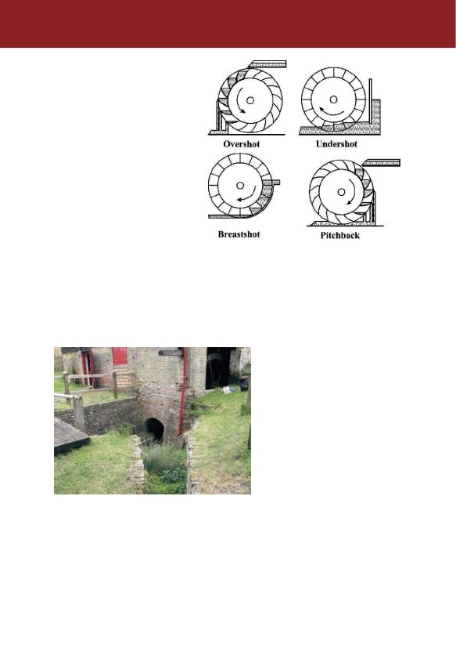
Overshot and pitchback wheels are
more efficient than the other types
because they are driven by the
weight of the water (1 cubic metre
(35 cubic feet) weighs 1 tonne
(2205 lb)) and by the force or
pressure of the water directed into
the buckets by the pentrough. Both
overshot and pitchback wheels
require a good head of water that
is the difference between the level
of the water in the millpond and in
the tailrace (channel to the stream
below the mill). At Ford End, this is
some 4.3m (14 ft).
The power transmitted by the
wheel is determined by the
discharge of water flowing on to it, that is, by flow (mass per unit time) and fall. The
flow is controlled by the penstock, which is raised and lowered by a rack and pinion
turned by a lever on the second floor (stone floor) within the mill. The higher the
penstock is, the greater the discharge of water. The waterwheel at Ford End
generates about 7460watts (10 horsepower).
The Sheepwash
The next stop on the tour is the
sheepwash by the bridge below the
waterwheel. Here, step back in
time to the 18th Century and think
about how the resourceful millers of
the day improved their income.
Millers at that time needed to
supplement their living from milling
and dealing with animal feed and
flour by diversifying into other
activities. They had orchards
providing apple wood which, when
seasoned, was used for wooden

cogs for their mills’ wheels. They kept pigs which were fed with sour flour, unsuitable
(dirty) grain and rotten apples - in some mills, pigsties have survived to this day. And
with a readily available water supply they could also wash sheep brought to the mill
by local farmers as was done here at Ford End. The washing made shearing much
easier and a clean fleece commanded a better price at market. This was not sheep
dipping, which has been a more recent process using chemicals.
5

On arrival the sheep were held in flocks in the area now used as the car park and
when their turn came, they were moved down to the front of the mill and penned in
the bricked area. They were then dropped, one at a time into a pool about 1.5m (5ft)
deep created by placing boards across the tailrace between the two posts at either
end of the wooden bridge below the mill. A farm hand suitably clad in sou’wester and
oil skins, stood in the square cast iron box (or pulpit) pulling each sheep in turn
towards him using a “T” shaped crook (take a look for the one still in the mill). Then,
he dunked the sheep in the pool and most probably held it under the cascade of
water pouring from the wooden chute protruding from the wheelhouse wall. When its
fleece was clean, the sheep swam along the brick-lined channel until its feet touched
the bottom and it could walk out into the field opposite the mill to dry out.
In his accounts ledger for 1915, the only surviving contemporary record of events at
Ford End, the farmer and miller, Charles Jellis, recorded that between 15 th and 24th
May 1915, 600 (30 score) of F Warren’s sheep were washed at a charge of 5p per 20
(one shilling per score). That was just over one halfpenny each. £1 in 1915 would
be worth about £62.50p today and thus the price for washing sheep in today’s prices
would be around 16p each.
The photograph to the right, taken
in 1939, shows that the water was
conveyed from the mill pond to the
sheepwash by an inclined narrow
wooden trough running alongside
the waterwheel. The trough
protruded from a square hole to
create the water cascade. It had
its own small sluice gate to control
the flow of the water and when the
millpond was drained in March
2003 its position was discovered
on the side of the pentrough.
Only the upright posts and the top cross strut of the sheepwash remain today and the
level of the field opposite has been raised so that the brick-lined channel leads
nowhere. However the pulpit survives and a replica chute has been fitted to the
wheelhouse wall. The Society hopes to restore the sheepwash in the future.
The Mill Building
Take a look at the mill building after you have re-traced your steps across the bridge
over the Whistle Brook. It has three floors – the ground floor called the meal floor;
the first floor called the stone floor, and the second floor called the bin floor.
6

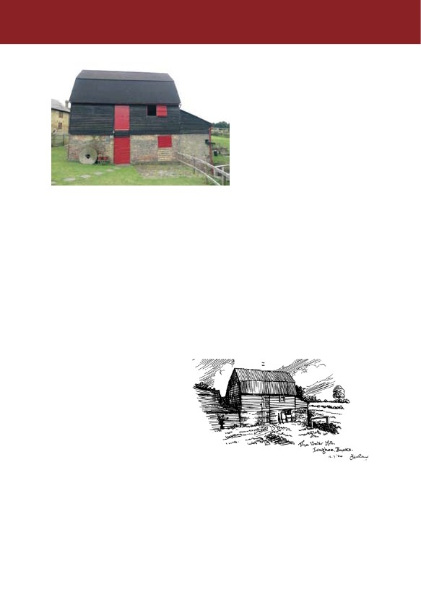
It’s a very traditional building. The
walls of the meal floor are
constructed of local red brick
interspersed with burnt glazed
bricks. The upper storeys are
constructed within a strong timber
frame with heavy beams and joists.
The beams supporting the bin floor
are pitch pine. All the floor boards
are metal tongued and grooved.
Many of the timbers have been
either re-used from the mill or
obtained from other buildings.

Those in the back wall of the stone floor, which are thought to date from the 17th
century, can be recognised by their shape, joints and peg and mortise holes. The
two wooden upper storeys are weather boarded on the outside to protect against
wind and rain.
Originally the mill had a common pitched roof with peg tiles – documentary evidence
of the retiling of the mill in 1830 confirms this. Towards the end of the 19 th century,
possibly because of damage or deterioration, instead of retiling, the roof was “tinned”,
ie covered with galvanised corrugated iron. This method of roofing for farm buildings
was in regular use by the 1860s. The mansard roof (a roof with two slopes with the
lower one steeper than the upper) was constructed at the same time to give more
space and headroom on the bin floor. Originally the water wheel was open, but it
was enclosed later by the wheel-house built from yellow Foxen bricks made locally
near Cheddington station. It too has a corrugated iron roof.
The external appearance of the mill has been much altered over the years to suit the
needs of both miller and farmer. Adjacent to the mill, there used to be several barns,
long since demolished, which were
used for storage etc. The bricked-
up doorway, which used to provide
access to these barns, can be seen
in the rear wall of the meal floor just
below the stairs.
On the stone floor, there used to be
a small square opening cut in the
weather boarding just behind and
above a chaffcutter, which was
used to chop straw into short
lengths for animal feed and bedding. The opening was to let out the noise of the
chaffcutter when the shutters were closed during inclement weather. When the mill
was “re-boarded” in the early 1980s, this opening was not reinstated.
7

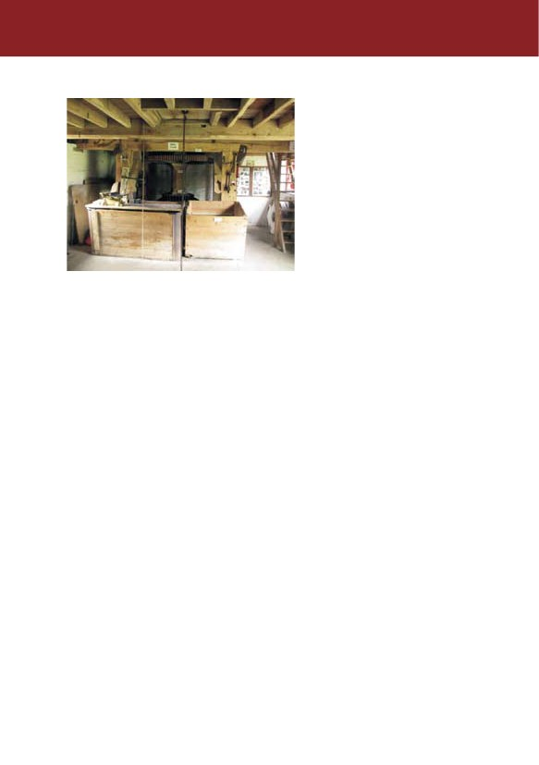
The Meal Floor
You enter the mill at the meal floor
so called as this is where the meal
(the product of grinding before any
further processing) was delivered
from the millstones above for
bagging via meal spouts (wooden
chutes). You will be aware
immediately of the main beams
supporting the stone floor above.
These are made of poplar, a wood
much favoured in the middle of the
18th century and the fibrous nature
of the beams can be readily seen.
It is on this floor that power from the waterwheel is delivered by its axle to the large
pit wheel. As its name suggests, this wheel is placed over a pit because of its size.
It is made of cast iron in two halves and is clamped on to the waterwheel axle. The
pit wheel’s cogs, which are made of wood, mesh with the iron teeth of the wallower
mounted on the vertical wooden main shaft. As the wallower is a bevel gear-wheel, it
converts the drive from the horizontal to the vertical and as it is smaller than the pit
wheel, it means that the main shaft rotates faster than the pit wheel and in a
clockwise direction. Above the wallower is the large cast iron spur wheel, again with
wooden cogs, which transmit the drive up to the two iron stone nuts. These are
lowered by a jack ring to engage with the spur wheel so that the drive can be
passed to the runner stones (the rotating upper stones) for milling. The millstones
at Ford End turn anti-clockwise. The diagram in the centre pages of this guide shows
a section through the mill positioning the machinery described above.

As with most contemporary mills, all the gears intermesh wooden cogs with iron
teeth. There are several sound reasons for this. First, as the wooden cogs are
detachable, they can be quickly and easily replaced when worn or broken, meaning
little loss of milling time. In contrast, if iron teeth were broken, the miller would have
had to have a complete new gear wheel cast. This would be very expensive
not least as it would result in significant loss of milling time.
Replacing one or two broken wooden cogs is a simple and inexpensive task that a
miller could perform. Secondly, the smooth-wearing qualities of the wood minimises
wear on the iron gears and so extends their life as well as contributing to the quiet
and even running of the mill. Thirdly, by preventing sparking, the risk of fire, which is
the miller's nightmare, is greatly reduced.

The preferred wood is well-seasoned apple or hornbeam although beech will
suffice.There are examples of old and new wooden cogs on display in the mill. In
some regions, the gearing was enclosed by wooden boards. Here, the boarding has
been removed to allow the gearing to be observed. The covering boards are stored
against the wall on the meal floor to the left of the gearing. Also on this floor, you will
find the ends of the sack hoist rope and sack hoist chain for lifting sacks to the bin
floor. You will have the opportunity to raise a sack yourself.

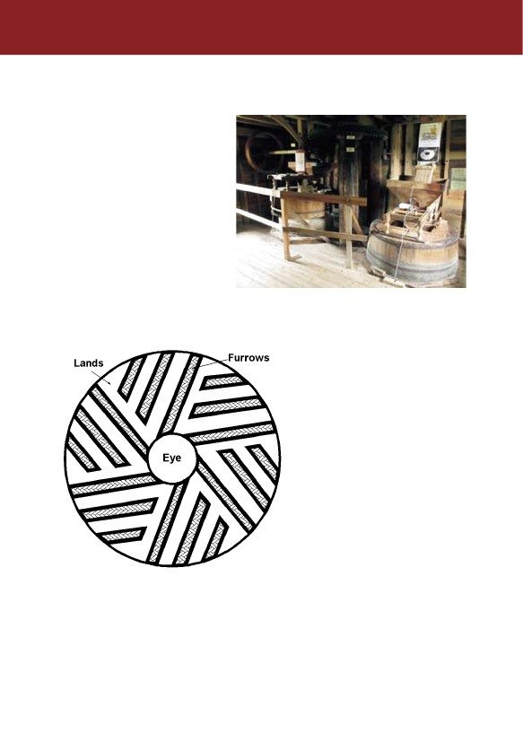
The Stone Floor
Take one of the two sets of stairs
up to the stone floor, so named as
this is where the millstones are.
Please mind your head and bear in
mind that when you come down
again you will need to come down
backwards for safety reasons.
There are two sets of stones at
Ford End. Facing the stones, the
set to the left, which is no longer
operational, was for animal feed.
The set to the right, which is
operational, is for flour. To make
animal feed, the miller used the

coarser peak stones of Millstone Grit, a coarse-grained sandstone quarried in the
Peak District of Derbyshire. They were used to mill wheat for flour and oats or barley
for feed until about the mid-1800s after which their use was generally restricted to
animal feed.
For the fine milling required for the
production of flour much harder
stones are required. At Ford End,
French burr stones are used to
produce flour. These are made up
of shaped blocks of chert, a very
hard form of quartz, formerly
quarried near Paris. The blocks are
bound together by iron strap hoops
for greater security. Over time, the
milling surfaces wear down and
have to be “dressed”, that is re-
cutting of the grooves (or furrows)
to make them sharp and the
grinding surfaces (or lands) to make
them rough again. The degree of
wear depends on the amount of
usage and the miller would only
have the stones dressed when he judged they were no longer milling efficiently.
Dressing was usually carried out by a millwright but many millers were capable of
undertaking it themselves. The pattern of the furrows cut into the grinding surface
is shown in the diagram of a runner stone above. The bed stone (the lower stone,
which remains stationary) has similar furrows and lands but has a smaller central
hole through which the stone spindle passes.
9

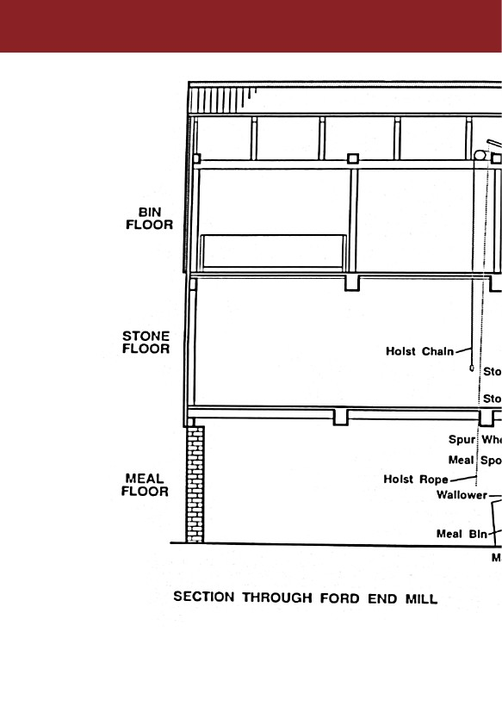
10

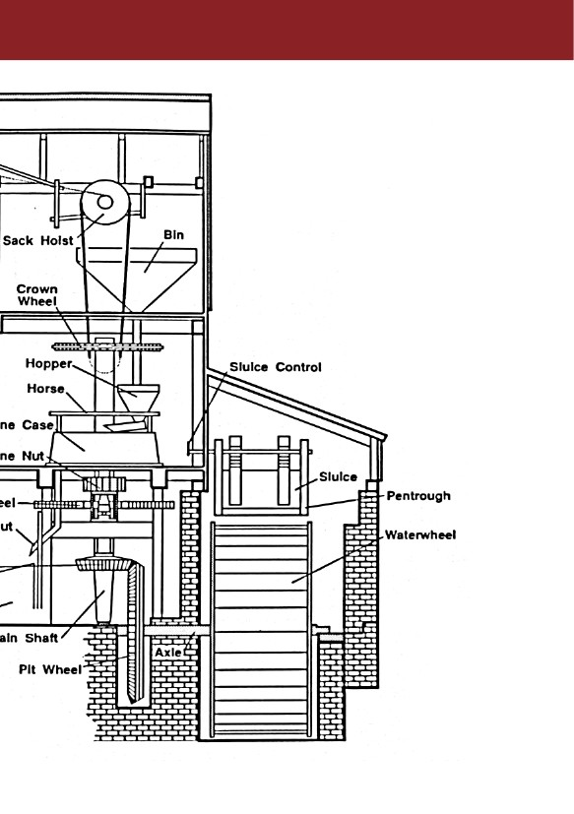
11

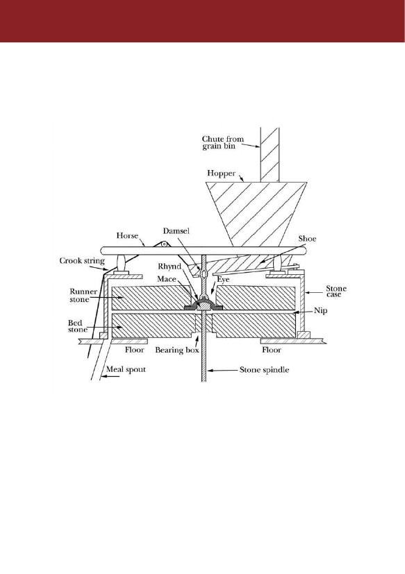
The stone resting against the front wall of the mill also shows this pattern of furrows.
The non-milling surfaces were rough and irregular so were coated with plaster of
Paris to make them level and smooth. This also improved balance and made
cleaning easier. It is the plaster which can be seen on the top of the runner stone not
the actual millstone. Both pairs of stones are enclosed in stone cases, sometimes
called vats or tuns, to prevent meal and dust escaping.
The runner stone turns on the bed stone and the scissor-like action of the furrows
slices the grain, which is then ground into meal as it passes between the grinding
surfaces (lands) on its way to the edge of the bed stone. From here it falls to the
floor inside the stone case and a sweep or paddle attached to the rotating runner
stone sweeps the meal to a hole in the floor. This is the mouth of the meal spout,
which takes the meal down to the ground floor where it is bagged and weighed.
Before setting the mill working, the miller would have filled the hopper above the
stones by pulling out the slide in the chute allowing grain to flow into it from the bins
on the floor above. Today, the hopper immediately above the stones is filled directly.
The next task is to wind down the stone nut with the jack ring on the meal floor so
that it meshes with the cogs of the spur wheel. This can only be done when the mill
12

waterwheel is stationary otherwise most of the wooden cogs would be badly
damaged.
To start the waterwheel turning, the miller opens the sluice gate to allow the surge of
water along the pentrough. This done, he hurries downstairs to begin milling. He
quickly lowers the top runner stone, which had been resting just clear of the bedstone
and when their surfaces close together the grain is trapped and ground into meal.
Raising or lowering the runner stone increases, or decreases the gap between the
stones, an operation called tentering. This gap (the nip), determines the fineness of
the meal - the smaller the nip the finer the meal. Tentering is carried out by turning
up or down the large nut on the threaded rod just beside the meal spout. This moves
the bridge tree (an adjustable iron beam supporting the lower end of the stone
spindle) which in turn raises or lowers the runner stone. This device enables the
miller to make minute adjustments to the nip.
So that the miller can monitor the rate at which grain is being fed into the runner
stone from his working position by the meal spout on the meal floor, he listens for the
damsel. This is a vertical metal shaft, with four lobes, or arms forming a square at its
middle, which protrudes from the eye of the runner stone and rotates with it. The
damsel was so named, apparently, because of its incessant chattering! As the
damsel rotates, its arms strike against the angled shoe below the hopper to jog the
grains along so that they fall into the eye of the runner stone. The angle of the shoe
can be adjusted from the floor below by the crook string to decrease, or increase
the amount of grain being fed into the stones. The speed of the runner stone and the
rate of grain being fed into the stone and the adjustment of the nip determine the
quality of the meal.
To warn the miller when the grain in the hopper is running low, he relies upon a bell
fixed to the horse, a wooden frame supporting the hopper. The bell is kept out of
contact with the damsel by a strap held down by the weight of grain in the hopper.
When the grain is low and the weight reduced the strap is released allowing the bell
support to fall forward against the rotating damsel causing the bell to ring, so warning
the miller that the hopper needs refilling.
At the top of the main shaft on the stone floor you will see the iron crown wheel with
its wooden cogs. Its purpose is to transfer the drive, again through a right angle by
means of an iron bevel gearwheel to the horizontal lay shaft, on which are mounted
two pulleys for driving ancillary machinery.
One pulley drives the sack hoist and to set it in motion, the miller tightens the drive
belt by pulling on the sack hoist rope, which passes through each floor. The sack
hoist chain, which is secured to the winding drum on the bin floor, also passes
through each floor to the ground floor. Here it is looped around the neck of the sack
of grain which is then raised up through two sets of clapper or trap doors up to the bin
floor. Releasing the rope slackens the belt and disconnects it from the drive allowing
the sack to be emptied into the storage hoppers and bins.
The other pulley drove the chaffcutter, which is a relatively modern machine from
1922 with an ingenious safety device so designed that should the worker’s fingers
become caught in the spiked feed rollers, he could push the trip handle forwards to
13

reverse the feed rollers and so release his fingers. The idea seems to have been to
prevent his already injured fingers being amputated by the rotating blades! However,
the reversing action would injure them a second time.
There is also a hand driven winnower on the stone floor. The purpose of this
machine was to clean the grain and consequently improve the grist (grain to be
milled) by removing weed seeds, straw, dirt and other contaminants using a rotating
fan (blower) and a series of vibrating sieves. The winnower was made by Kell Meats
& Co. of Gloucester for manual operation using a handle. It came originally from
Horton Manor near Slough and has been restored to working order. With re-
positioning, this could be converted to be driven by a belt from the lay shaft pulley.
The Bin Floor
The final climb is up the stairs to
the bin floor, where the grain is
kept in large bins. This is where,
in past centuries, grain in sacks
hoisted from the ground floor was
delivered for emptying into these
bins. Grain from the bins fed down
to the hoppers above the mill
stones.
On this floor, you will also see a
saddle stone and a rotary quern.
These provide some insight to the
ways used to make grain edible in
earlier times. Ever since man first
grew cereals such as wheat, oats and barley for food, he has had to break down the
grain by grinding. One of the earliest methods was simply to pound the grain
between two stones. From these, the pestle and mortar evolved, with the grain being
pounded and rubbed by the pestle in the mortar. There followed the use of a flat
stone, which became curved through usage, hence its name – saddle stone. The
grain was placed on the stone and rubbed with a smaller stone called a muller. The
saddle stone here on the bin floor is from the Iron Age some 2300 years ago. It was
ploughed up in a field near Pitstone Green
Farm. The rubbing action was a true grinding
process, as opposed to the earlier methods of
pounding which only crushed the grain.
The rotary quern was a marked improvement. It
had two circular stones, a bottom one which was
flat or slightly convex and a top one shaped like
an up-turned bowl fitted with a wooden handle
and with a hole, the eye, in its centre. Grain,
dropped a little at a time into the eye, was
ground by rotating the top stone with the handle.
It emerged as meal at the edges of the stones.
14
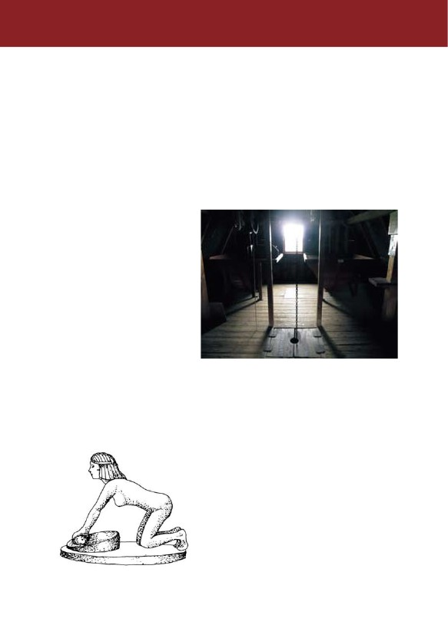

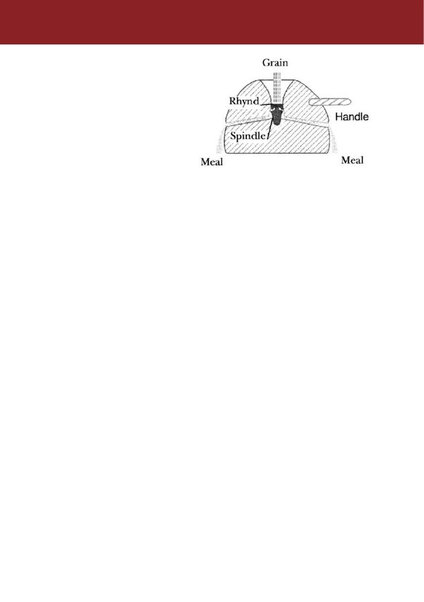
Part of a Romano-British quern is
displayed in the mill. It is made of
Hertfordshire pudding-stone and
was found in a well dating from the
2nd century AD on land below
Pitstone Hill which became No. 2
Quarry serving the now closed
cement works in Pitstone. The
other quern is modern and was
imported from India where such
querns are still being made for
village use.
This principle of grinding by feeding grain into the eye of a circular stone turning upon
another is used in all stone mills such as Ford End - indeed power driven millstones
are essentially little more than large, power driven querns. Water power has been
used for more than 2000 years, the Greeks being credited with adapting it to milling
cereals in the first century BC. The Romans also used grain watermills and
introduced them into Britain. The Saxons are known to have had numerous
watermills. The Domesday Survey in 1086 following the Norman conquest lists more
than 5600, a figure meriting caution since an individual pair of stones may have been
recorded as one mill. The Survey lists 137 watermills in Buckinghamshire.
From the 12th century onwards, the number of watermills increased significantly,
most of them belonging to either a manor or a monastery. The dissolution of the
monasteries in the 1530s, followed later by improvements in farming methods, by
changes in the eating habits of an increasing population and by the development of
better transportation, all contributed to the establishment in the late 18th century of
the independent miller, who milled for a living. The heyday of the water driven stone
mills lasted from the mid 18th century to the end of the l9th when they were largely
superseded by the advent of steam and eventually by more efficient roller mills driven
by water turbines or electric power and using spirally grooved steel rollers instead of
mill stones. They were capable of producing large quantities of meal which, after
purification became the fine white flour then much in demand, a demand which could
not be satisfied by stone mills with their intermittent water supply.
Please re-trace your steps back down to the ground floor where your tour ends. You
will be able to purchase the flour milled here. It is a popular purchase and a number
of visitors come especially to buy it. As with the other merchandise on sale, all
proceeds go to keeping this historic mill operational. Do ask any of the volunteers if
you have any outstanding questions. They may not be able to answer all your
queries but they will know someone who can. Have a safe journey home and . . . .
do come again.
15

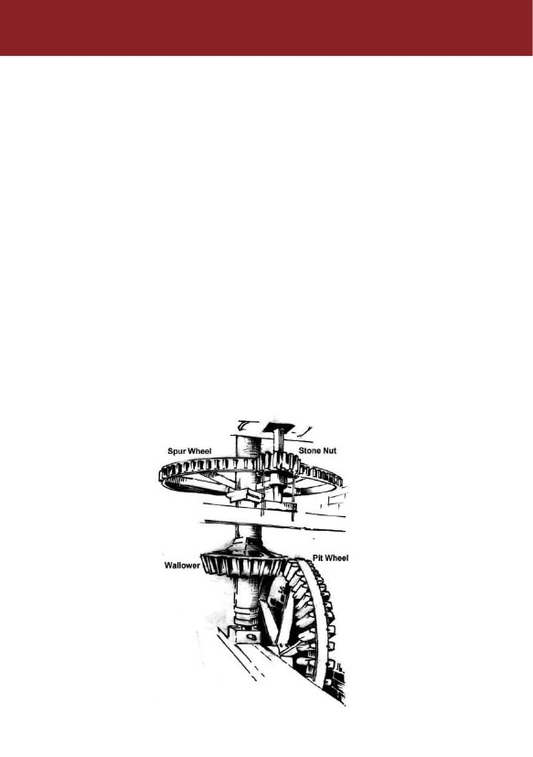
Gearing up - the mathematics
How quickly does the runner stone rotate? This can be calculated knowing the
number of teeth on the relevant wheels and by estimating the speed of the
waterwheel. The wheels, which carry power from the waterwheel to the runner
stone, are the pit wheel, the wallower, the spur wheel and the stone nuts. The
number of teeth on each of these gear wheels is, as follows:
Pit wheel – 92
Wallower – 33
Spur wheel – 122
Stone nuts – 23.
For completion, you may be interested that the Crown Wheel has 73 teeth and the
Lay Shaft bevel has 20. The gear-wheels alternate between large and small, by
which means their speed is increased in direct proportion to the lesser number of
teeth on each successive cog. So, the speed of the runner stone related to the
speed of the waterwheel can be calculated as: 92/33 x 122/23 ie 14.8.
We can approximate this to 15 revolutions of the runner stone for each revolution of
the waterwheel. Thus, if we estimate that the waterwheel is running at 6 revolutions
per minute then the runner stone will be running at 90 rpm.
16

Glossary
Axle (or axle tree) - cast iron shaft on which the water wheel and pit wheel are mounted.
Bed stone
Bridge tree
- the lower fixed millstone.
- adjustable metal beam supporting the bottom of the stone
spindle - used to vary the 'nip' when tentering.
- metal (formerly wood) sheets forming the waterwheel buckets.
- enclosures or containers on the circumference of the wheel
formed by the boards to trap and hold the water.
- machine used to chop straw into short lengths for animal feed
and bedding.
- cord by which the inclination of the shoe is adjusted.
- cast iron gear-wheel with wooden cogs at the top of the main
shaft – drives the lay shaft
- rotating vertical metal bar, split into four to form a square at its
middle, which agitates the shoe to ‘jog’ the grains into the eye
of the runner stone
- hole in the centre of the runner stone into which the grain falls
from the shoe.
- millstones made of interlocking blocks of chert - a form of quartz
which used to be quarried near Paris. The blocks are held
together by iron hoops and Plaster of Paris.
- grain for grinding
- channel or millrace (including the leat or lade and pentrough)
along which the water flows to the wheel.
Boards
Buckets
Chaffcutter
Crook string
Crown wheel
Damsel
Eye
French burr
stones
Grist
Headrace
17

Head of water
- the difference between the upper water level (in the millpond)
and the lower level (at the tailrace).
- wooden frame on top of the stone case supporting the hopper
and shoe; the 'low grain level' warning bell is attached to it.
- metal ring below the stone nuts; raised and lowered by a handle
on a threaded rod; disengages and engages the stone nut from
the spur wheel.
- shafting with pulleys used to drive the chaffcutter and sack hoist;
drive taken from the crown wheel through a bevel gear-wheel.
- product from grinding, before any further processing.
- the gap between the millstones, adjusted by tentering.
- millstones of Millstone Grit (coarse-grained sandstone) quarried
in the Peak District of Derbyshire.
- sluice gate fitted within the pentrough to control the flow of water.
- trough carrying the water from the millpond to the top of the
waterwheel.
- first gearwheel inside the mill, made of cast iron with wooden
cogs and located over a pit - hence its name - and mounted on
the same axle as the waterwheel.
- upper millstone which rotates.
Horse
Jack ring
Lay shaft
Meal
Nip
Peak stones
Penstock
Pentrough
Pit wheel
Runner stone
Shoe (or Slipper) - tapering, inclined wooden chute or tray which conducts the grain
from the hopper into the eye of the stones.
Shrouds
- circumferential outer casings on each side of the waterwheel;
form the buckets with the boards.
18

Sluice (gate)
- wooden gate within the pentrough which is raised or lowered to
control the amount of water flowing on to the waterwheel by
which the speed of the waterwheel and hence the runner stone is
determined.
- cast iron wheel with wooden cogs; transfers the drive from the
main shaft to the stone nuts.
- wooden casing enclosing the stones.
- cast iron gear-wheel (pinion) which transfers the drive from the
spur wheel to the stone spindle.
- vertical shaft supporting and driving the runner stone.
- heavy boards placed across the entrance to the pentrough to
stop the flow of water in case of emergency or problems with the
pentrough or sluice gate.
- channel along which water flows from below the waterwheel.
- adjusting the gap or 'nip' between the runner and bedstone.
- cast iron bevel gear-wheel; transfers the drive from the pit wheel
to the main vertical shaft.
- machine, hand or power driven; removes seeds, chaff and dirt
from grain prior to milling.
Spur wheel
Stone case
Stone nut
Stone spindle
Stop planks
Tailrace
Tentering
Wallower
Winnower
19

Finding us again
Ford End Mill can be found at National Grid Reference: SP 941166 and the
Postal Code is LU7 9EA.
The mill is on the outskirts of the village of Ivinghoe, on Station Road (the
B488 to Leighton Buzzard), approximately 550 metres (600 yards) from the
church. Ford End Farm is on the left, and access is through the first gate
on the right inside the farm entrance. The mill is across the yard beyond
the farm buildings. Free parking is available in the yard.
© Ford End Watermill Society 2013
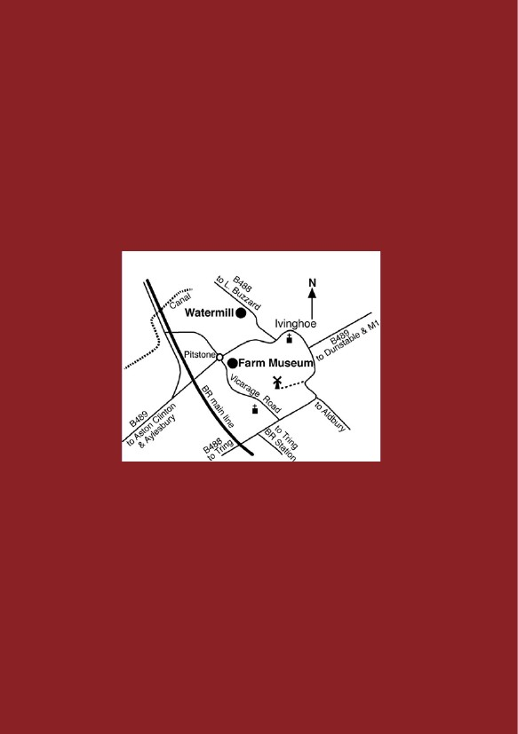
PARTIES: School and other parties are most welcome by prior arrangement
that can be made by telephoning 01296 660074. Email: jill.graves@sky.com
A society member will act as a guide. Unaccompanied children cannot be admitted.
General Enquiries, Contact Mill Manager Chris Tugby 01442 825421
Email: millman@fordendwatermill.co.uk
OPENING TIMES: The mill is normally open to the public between 2:00 and
5:00 (last entry 4:30pm) on certain Sundays and Bank Holiday afternoons
from the beginning of spring to the end of September. Milling
demonstrations are given regularly from early spring until September.
FACILITIES: There are no toilet facilities and whilst handicapped visitors
are very welcome, access to the upper floors could be difficult.

